Assignment 14 Modify your measurement table to include 4 different pictures using the following tag:
<img src="XXXXXX" height="150" width="150">
PLACE THE CODE IN THE CELL OR PARAGRAPH YOU WANT IT TO APPEAR
Use the file name and extension from the folder. For example the first and second picture will be
<img src="robot2.jpg" height="150" width="150">
<img src="robot2.jpg" height="150" width="150">
Look at the picture below for help

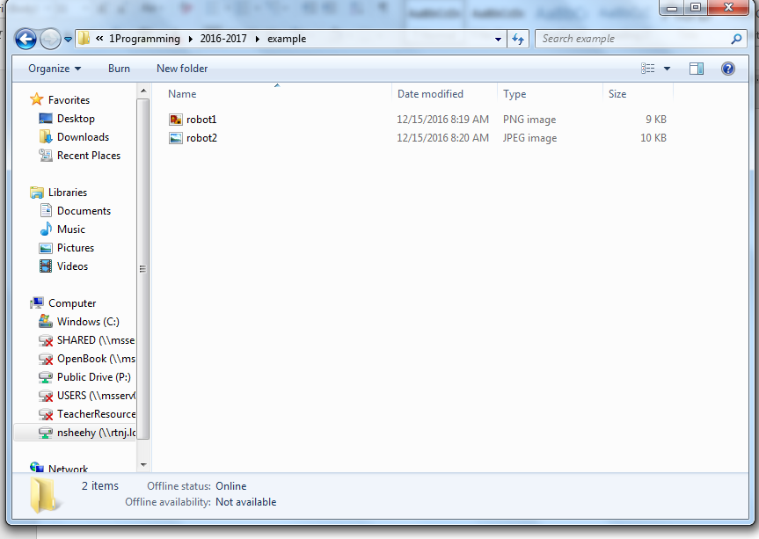
The second name will be robot2.jpg
The first name will be
Robot1.png
The second name will be robot2.jpg

